**1). Write a C program to find out the Maximum and Minimum number from given 10 numbers.**

**CODE 1 :**

/*Write a C program to find out the Maximum and Minimum number from given 10 numbers */

#include <stdio.h>

int main()

{

int a[10], i, min, max;

for (i = 0; i < 10; i++)

{

printf("\n Enter Integer Value [%d] : ", i + 1);

scanf("%d", &a[i]);

if (i == 0)

{

min = max = a[i];

}

else

{

if (min > a[i])

min = a[i];

if (max < a[i])

max = a[i];

}

}

printf("\n Minimum : %d", min);

printf("\n Maximum : %d", max);

return 0;

}

**OUTPUT 1 :**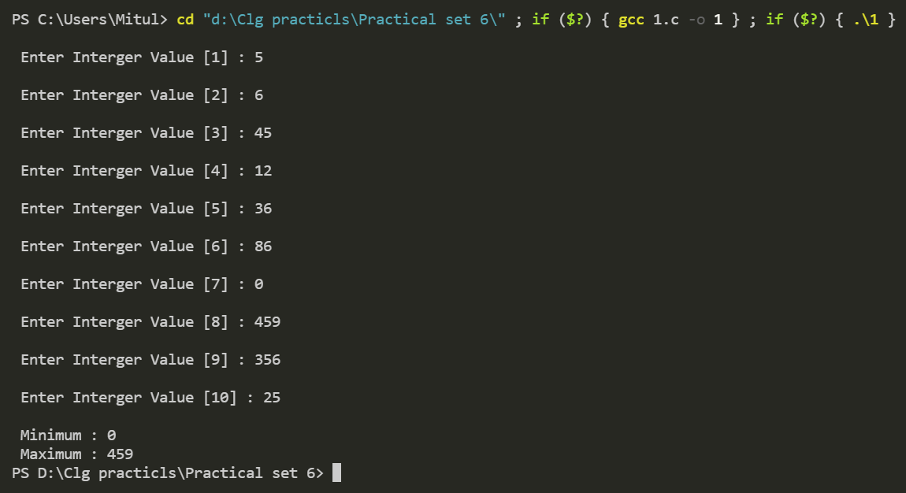

**2). Write a C program to input an integer number and check the last digit of number is even or odd.**

**CODE 2 :**

/*Write a C program to input an integer number and check

the last digit of number is even or odd. */

#include <stdio.h

int main()

{

int a, b;

printf("Enter The Integer : ");

scanf("%d", &a);

if ((a % 10) % 2 == 0)

printf("The last digit of number is even.");

else

printf("the last digit of number is odd.");

return 0;

}

**OUTPUT 2 :**

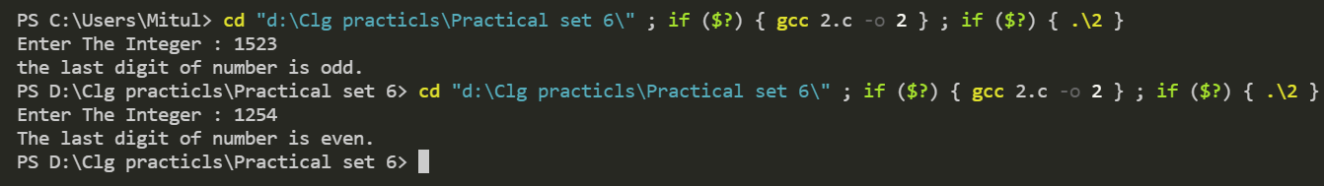

**3). Write a C program to find factorial of a given number.**

**CODE 3 :**

/*Write a C program to find factorial of a given number. */

#include <stdio.h>

int main()

{

int a, f = 1;

printf("Enter the number to find factorial of : ");

scanf("%d", &a);

for (int i = a; i > 0; i--)

{

f = f * i;

}

printf("The factorial of %d is %d .", a, f);

return 0;

}

**OUTPUT 3 :**

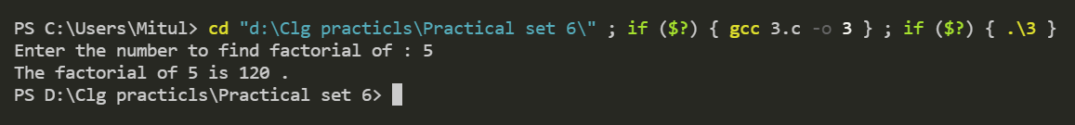

**4). Read five persons height and weight and count the number of person having height greater than 170 and weight less than 50.**

**CODE 4 :**

/*Read five persons height and weight and count the number of person having height greater than

170 and weight less than 50,*/

#include <stdio.h>

int main()

{

int person, height, weight, count = 0;

for (person = 1; person < 6; person++)

{

printf("\n Enter Detail of Person - %d", person);

printf("\n Enter Height : ");

scanf("%d", &height);

printf("Enter Weight : ");

scanf("%d", &weight);

if (height > 170)

{

if (weight < 50)

{

count = count + 1;

}

}

}

printf("\n Total Person having Height > 170 and Weight < 50 : %d", count);

return 0;

}

**OUTPUT 4 :**

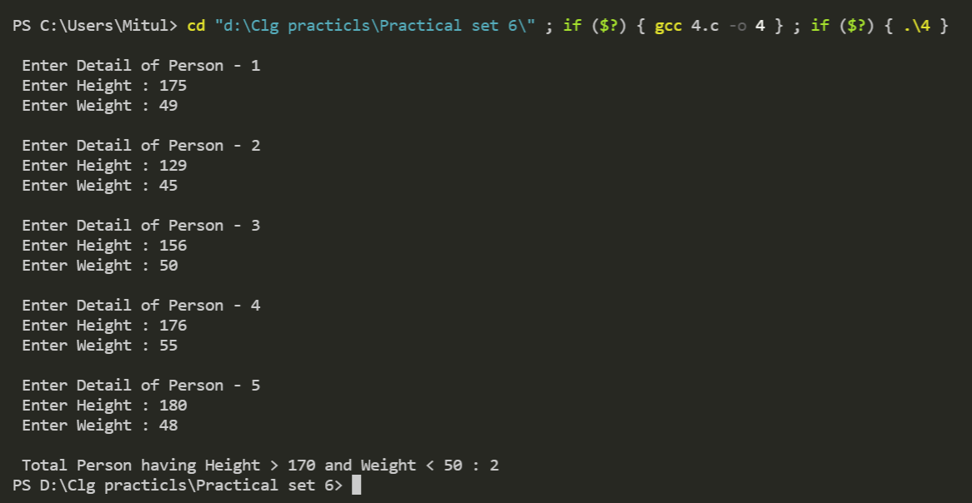

**5). Write a program to check whether the given number is prime or not.**

**CODE 5 :**

/*Write a program to check whether the given number is prime or not. */

#include <stdio.h>

int main()

{

int n, i;

printf("Enter the Positive integer : ");

scanf("%d", &n);

if (n == 1)

{

printf("1 is neither prime nor non-prime.\n");

}

for (i = 2; i < n; i++)

{

// condition for non-prime

if (n % i == 0)

{

printf("The number is not prime");

break;

}

else

{

printf("the number is prime");

break;

}

}

return 0;

}

**OUTPUT 5 :**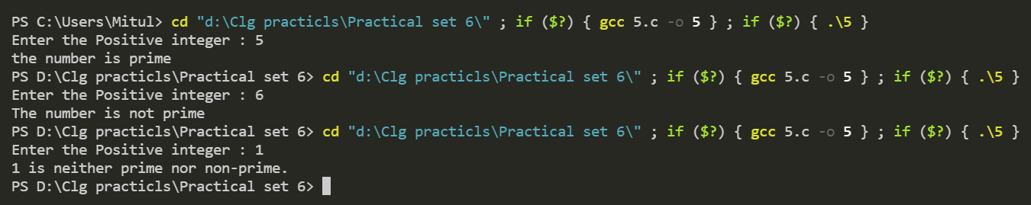

**6). Write a program to evaluate the series 1^2+2^2+3^2+……+n^2**

**CODE 6 :**

/*Write a program to evaluate the series 1^2+2^2+3^2+……+n^2 */

#include <stdio.h>

#include <conio.h>

int main()

{

int n, i;

int sum = 0;

printf("Enter the n i.e., max values of series: ");

scanf("%d", &n);

sum = (n * (n + 1) * (2 * n + 1)) / 6;

printf("Sum of the series : ");

for (i = 1; i <= n; i++)

{

if (i != n)

printf("%d^2 + ", i);

else

printf("%d^2 = %d ", i, sum);

}

return 0;

}

**OUTPUT 6 :**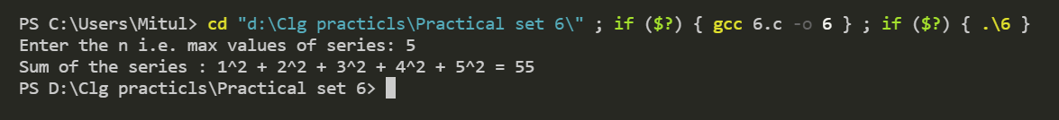

**7). Write a C program to find 1+1/2+1/3+1/4+....+1/n.**

**CODE 7 :**

/*Write a C program to find 1+1/2+1/3+1/4+....+1/n.*/

#include <stdio.h>

#include <conio.h>

int main()

{

double number, sum = 0, i;

printf("\n enter the number ");

scanf("%lf", &number);

for (i = 1; i <= number; i++)

{

sum = sum + (1 / i);

if (i == 1)

printf("\n 1 +");

else if (i == number)

printf(" (1 / %.lf)", i);

else

printf(" (1 / %.lf) + ", i);

}

printf("\n The sum of the given series is %.2lf", sum);

return 0;

}

**OUTPUT 7 :**

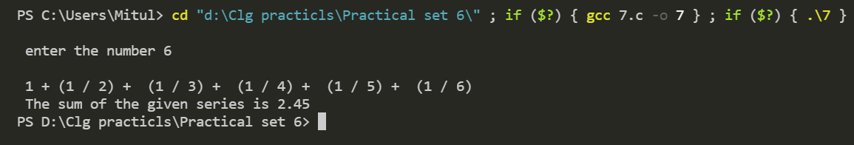

**8). Write a C program to generate the series up to term < 200**

**1 – 4 + 9 – 16 + 25 ….**

**CODE 8 :**

/*Write a C program to generate the series up to term < 200

1 – 4 + 9 – 16 + 25 …. */

#include <stdio.h>

int main()

{

int n, i = 1;

printf("Enter the range of number(Limit):");

scanf("%d", &n);

while (i <= n)

{

if(i%2==0)

printf("%d,", -i * i);

else

printf("%d,", i * i);

i++;

}

}

**OUTPUT 8 :** 